Unit 4: Solving Quadratics (Notes 4.2) Name:________________

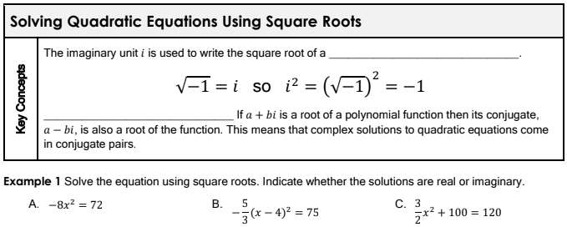
Solving Notes 4.2: Solving by Square Roots and Completing the Square

2. $x^{2}=50$ 3. $3{\left(x-3\right)}^{2}=-99$ 4. $\frac{{\left(x-5\right)}^{2}}{3}=-8$

